📘 Module: JSON Schema & JSON Schema Validation
🔹 1. What is JSON Schema?
- JSON Schema is a JSON object that describes the structure of another JSON.
- It defines:
  - What properties are expected in response.
  - What data types they should be.
  - Which ones are required / optional.
- Think of it as a contract between client & API.
Example:
{
"type": "object",
"properties": {
"name": { "type": "string" },
"age": { "type": "number" }
},
"required": ["name", "age"]
}
➡️ means the API must return both name (string) and age (number).

🔹 2. Why do we need JSON Schema?
Let’s say your app shows:
“John Smith, your age is 35.”
If the API team accidentally removes the age property from response,
UI will show:
“John Smith, your age is undefined.”
That’s a breaking change.
Schema validation can catch this automatically —
if age is missing, test will fail immediately.

🔹 3. Why not just write assertions for every property?
- Works for tiny JSON (2–3 properties),
- But real API responses can have hundreds of keys.
- Writing assertions manually is time-consuming, repetitive, and error-prone.
✅ Schema validation handles all properties & types in one check.

🔹 4. How to create JSON Schema
You can generate schema automatically from an API response using online tools like:
Transform.tools → JSON to JSON Schema
Steps:
- Copy your API response from Postman.
- Paste it into the tool.
- It generates schema automatically.

🔹 5. Understanding a simple schema example
Response:
{ "tags": ["Science", "AI", "Space"] }
Schema generated:
{
"type": "object",
"properties": {
"tags": {
"type": "array",
"items": { "type": "string" }
}
},
"required": ["tags"]
}
Meaning:
- tags must be an array.
- Each item inside must be a string.
- Property tags is required.
- If tags returns numbers or becomes missing → test fails.

🔹 6. Complex example – Articles list
Response:
Big object with articles array → each article has slug, title, description, etc.
Json obj is:
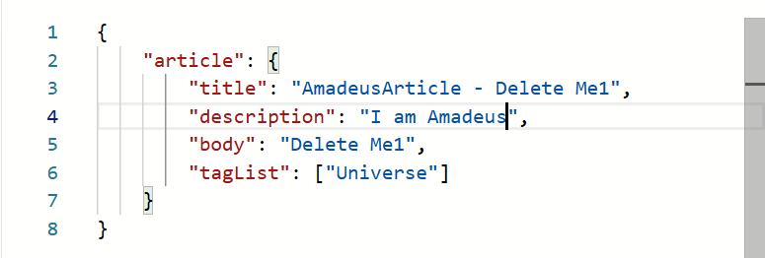
URL where we can give json object or data and it will generate JSON Schema:
JSON to JSON Schema
JSON Schema for above json obj is :
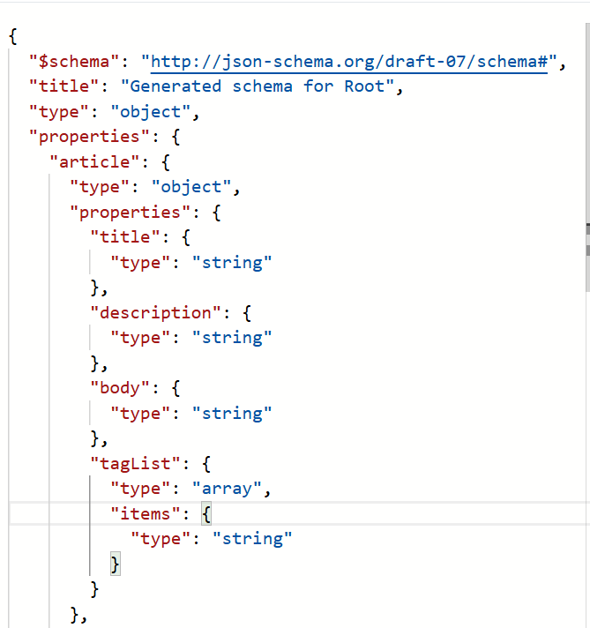
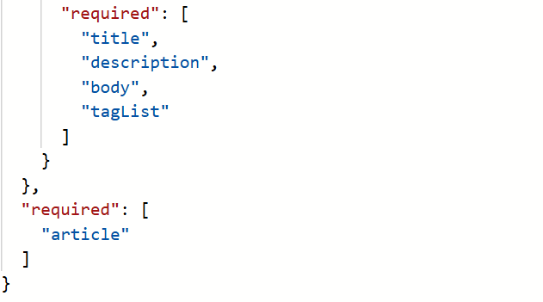
Schema automatically handles repetitive structure (each article).
If even one property or type mismatches, schema validation will fail.
🔹 7. Benefits of Schema Validation
✅ Detects missing or renamed fields
✅ Detects type mismatches (string → number, etc.)
✅ Works even for large JSONs
✅ Prevents integration issues early
✅ Acts like a contract check between API provider and consumer

🔹 8. Relation to “Contract Testing”
- There are 2 types of contract tests:
  - Consumer-driven contracts → consumer defines expectations.
  - Provider-driven contracts → provider (API) defines structure.
What we’re doing here (validating response using schema) =
👉 Provider-driven contract testing.
Schema acts as a contract of expected response from API.

🧩 JSON Schema & Contract Testing — Connection
✅ Yes — JSON Schema = Provider-Driven Contract Testing
- When you validate an API response against a JSON Schema,
you’re basically doing provider-driven contract testing.
- Why “provider-driven”?
→ Because the API provider (backend team) defines what the response structure should look like — and we (testers) validate that contract using the schema.
In short:
JSON Schema = the API provider’s contract
JSON Schema Validation = provider-driven contract testing

📄 Where does the JSON Schema come from?
👉 In real projects, you don’t need to build schemas manually for every endpoint.
You get them from API documentation sources, like:
- Swagger / OpenAPI docs
  - Swagger (or OpenAPI Spec) already contains:
    - Endpoint URLs
    - Request/Response structure
    - Property types, required fields, etc.
  - You can export JSON Schema directly from Swagger UI or .yaml / .json file.
- Confluence or internal API design documents
  - Sometimes teams maintain API contracts in Confluence (same data as Swagger).
  - You can copy the schema part and use it as your reference.
- Backend team
  - If Swagger doesn’t exist, you can ask backend devs to share the schema or OpenAPI spec file.

⚙️ How this fits into your framework
Your flow looks like this:
- Backend publishes API docs in Swagger.
- You extract the response JSON Schema for each endpoint.
- You store these schemas inside your Playwright API automation repo → /schemas folder.
- During test execution:
  - Call API
  - Validate response against schema
  - Fail test if schema mismatch found
📘 JSON Schema — Real-World Usage & Source of Truth
🔹 1. JSON Schema as a Contract
- JSON Schema defines what fields, data types, and structure an API response (or request) must have.
- When we validate API responses against this schema, it becomes a provider-driven contract test —
because the schema represents the API provider’s contract.

🔹 2. Where Do JSON Schemas Come From?
In real projects, you’ll get schema details from one of these sources 👇
🧩 a) Swagger / OpenAPI Documentation ✅ (most common)
- Swagger (or OpenAPI Spec) already contains the response structure,
including property names, types, and which are required.
- You can:
  - Export schema directly as JSON or YAML.
  - Copy the schema section for each endpoint and save it under /schemas in your framework.
- This is the official source — directly owned by the backend team.
🔸 Example:
In Swagger → open /policy → you’ll see response model (object type, fields, etc.)
→ you can copy that as your JSON Schema.

🧩 b) Confluence / Internal Docs
- Sometimes backend teams maintain API details in Confluence pages instead of Swagger.
- The page usually mentions:
  - Endpoint URL
  - Mandatory fields
  - Optional fields
  - Sample JSON request/response
- In this case, you can manually create the JSON Schema from that info using an online converter.
Example workflow:
- Copy the sample API response.
- Go to an online tool like Transform.tools JSON → JSON Schema or jsonschema.net.
- Paste response → tool generates JSON Schema automatically.
- Save it under /schemas folder in your project.

🧩 c) When Devs Only Share Curl Commands
- In some agile projects, devs just share curl commands like:
- curl -X POST https://api.qa/policy \
- -H 'Authorization: Bearer token' \
- -d '{"driverId":1,"vehicleId":2}'
- They might also tell you:
  - which fields are mandatory (e.g., driverId, vehicleId)
  - which are optional (e.g., policyType, comments)
- From this info and the sample response, you can still create your own JSON Schema manually or via online tool.
🔸 Example:
- Dev says:
  - driverId → required (number)
  - vehicleId → required (number)
  - policyType → optional (string)
- You create a simple schema:
- {
- "type": "object",
- "properties": {
- "driverId": { "type": "number" },
- "vehicleId": { "type": "number" },
- "policyType": { "type": "string" }
- },
- "required": ["driverId", "vehicleId"]
- }

In swagger , u can see schema section at last for each endpoint response where json response structure will be defined and mandatory and optional fields with data types.
From there u can try to create json schema with online tools.

